Article ID: 1063
Article Name: The Fabric Softener is going straight into the washer dryer machine drum
Topic Location: Laundry / Washer Dryer / Usage
Meta-data: Softener / clothes / smell
Related Articles:
Related Questions:
PNC
DIY
Safety
Link
Email
Book Engineer
Multimedia
Brand
Article Content:
Causes
1.- Overdosing the softener compartment.
2.- Push too hard the detergent drawer
Solutions
1.- Follow the indications of the instruction booklet avoiding overdosing the compartment.
2.- Close the detergent drawer softly at the beginning of each cycle.

The max level is indicated over the fabric softener cover:
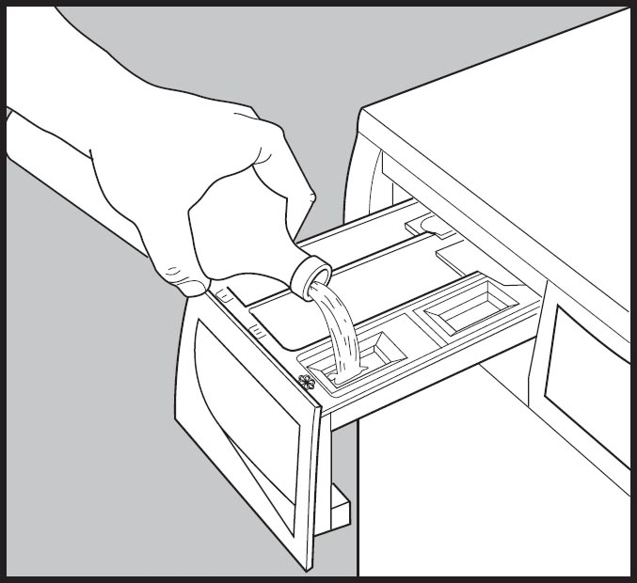
1063_WD_Softener_is_going_straight-IBR-20131107.jpg

